Name: ___________________________ Algebra - Homework Week 25
1. Solve the equation. -6(a + 1) – 4(-3 – 3a) = -5a + 8a

2. State the domain and range.
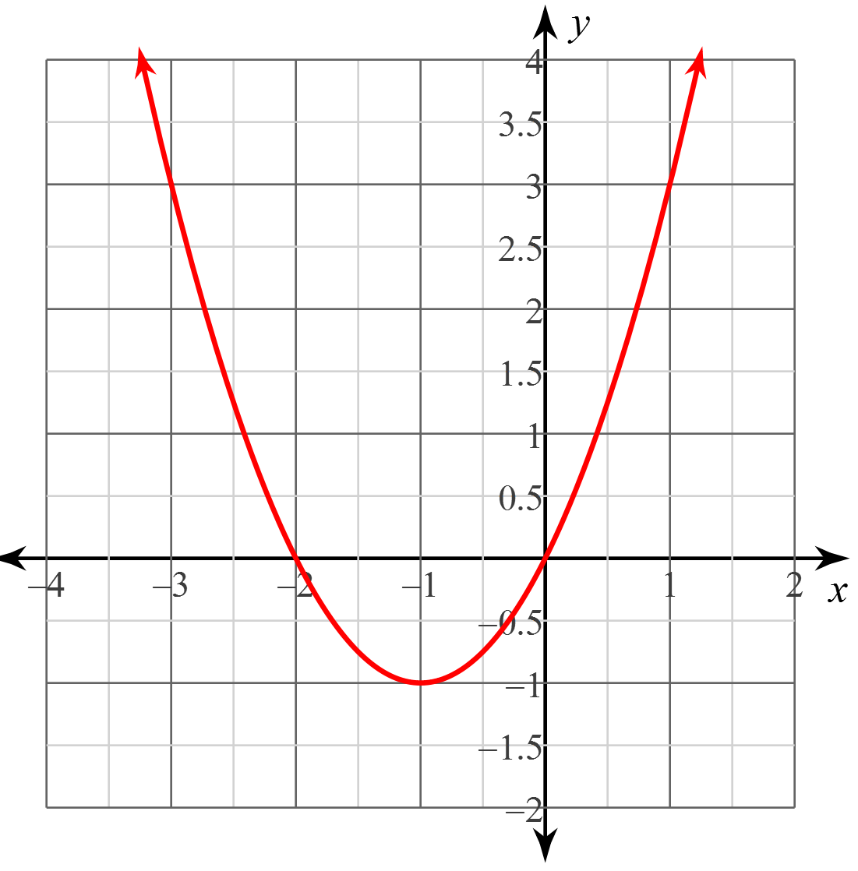

3. Write the equation in both slope-intercept and standard form for a line passing through (1, -1) and (3, -5).

4. Solve the system of equations.
16x – 20y = -16
8x – 10y = -8

5. Write and solve the system of equations.
A soccer match was held between Peru and Bolivia with 38,000 in attendance. Adult tickets sold for $8 and children’s tickets sold for $5. Total sales were $257,125. How many of each type of ticket was sold?

6. Simplify.
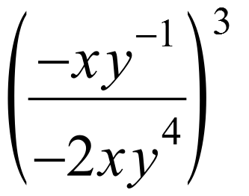
7. Factor as completely as possible. 9x² + 6x - 8

8. Write a verbal description of how this equation is different from the quadratic parent function. y = $\frac{-2}{3}$x² + 8.

Use the griddables below to answer #9 and #10.
9. What is the y-value of the vertex of the equation y = 3(x – 4)² – 6?
10. The graph of a linear function is shown on the grid. What is the rate of change of y with respect to x for this function?

